**DAILY ONLINE ACTIVITIES SUMMARY**

|  |  |  |  |  |  |  |  |  |
| --- | --- | --- | --- | --- | --- | --- | --- | --- |
| **Date:** | **04/06/2020** | | | | | **Name:** | **Lavanya D M** | |
| **Sem & Sec** | **4th & ‘A’** | | | | | **USN:** | **4al18cs041** | |
| **Online Test Summary** | | | | | | | | |
| **Subject** | | **MES** | | | | | | |
| **Max. Marks** | | **20** | | **Score** | | | **5** | |
| **Certification Course Summary** | | | | | | | | |
| **Course** | **Puzzle making** | | | | | | | |
| **Certificate Provider** | | | **Bitdegree** | | **Duration** | | | **2days** |
| **Coding Challenges** | | | | | | | | |
| **Problem Statement: Problem 1:** write a java program to read three integer values from the keyboard and find the sum of the values. Declare a variable "sum" of type int and store the result in it.  **Problem 2:** Write a C++ program to find the missing number in array | | | | | | | | |
| **Status: complied** | | | | | | | | |
| **Uploaded the report in GitHub** | | | | | **yes** | | | |
| **If yes Repository name** | | | | | <https://github.com/lavanyamurthi/lockdown-coding> | | | |
| **Uploaded the report in slack** | | | | | **yes** | | | |

Online Test Details: (Attach the snapshot and briefly write the report for the same)

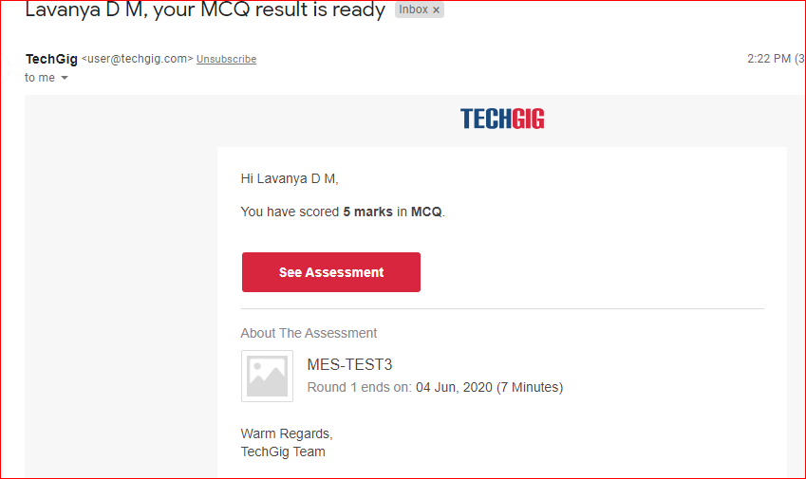

Certification Course Details: (Attach the snapshot and briefly write the report for the same)



This is the github link <https://github.com/lavanyamurthi/lockdown-certificate>

I started the new course how to make puzzle with bit degree

Coding Challenges Details: (Attach the snapshot and briefly write the report for the same)

Problem 1: Write a C++ program to find the missing number in array

Given an array C of size N-1 and given that there are numbers from 1 to N with one element missing, the missing number is to be found.

**Input:**  
The first line of input contains an integer T denoting the number of test cases. For each test case first line contains N(size of array). The subsequent line contains N-1 array elements.

**Output:**  
Print the missing number in array.

**Constraints:**  
1 ≤ T ≤ 200  
1 ≤ N ≤ 107  
1 ≤ C[i] ≤ 107

Example:  
Input:  
1  
5  
1 2 3 5

Output:  
4

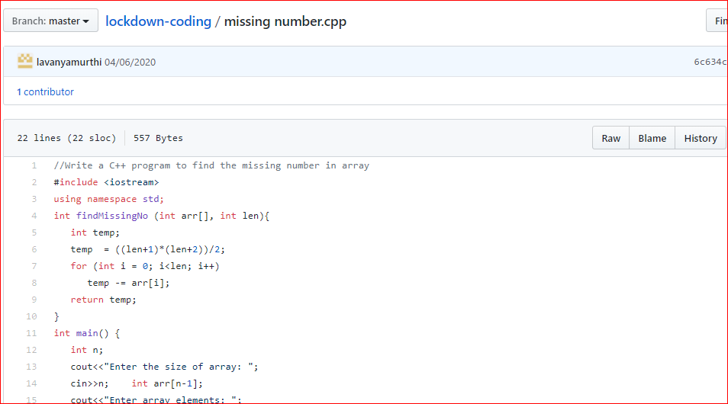

Problem 2: write a java program to read three integer values from the keyboard and find the sum of the values. Declare a variable "sum" of type int and store the result in it.

